Waleed Afzal

23p-0566

BS(CS) – 3D

CIVICS ASSINGMENT # 06

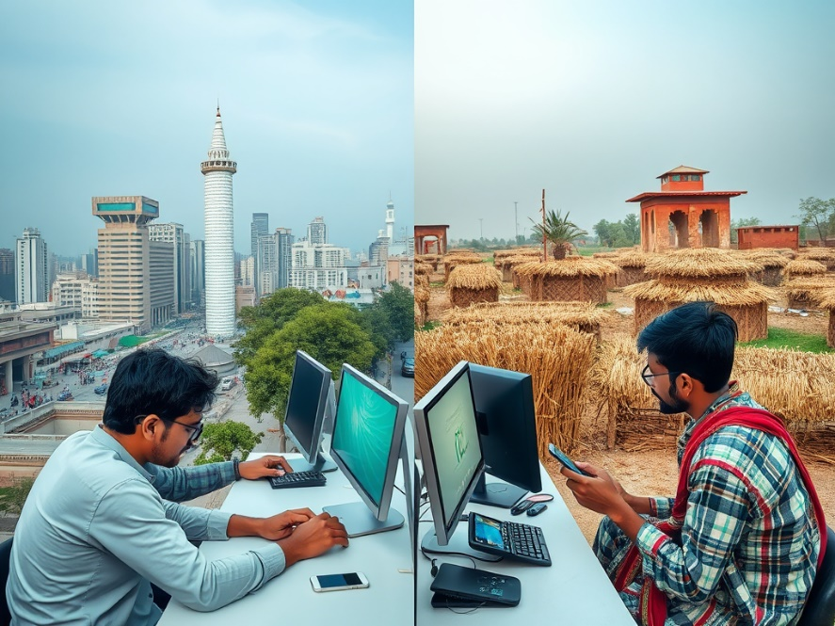

**Introduction:**

The digital divide refers to the unequal access to modern technology and digital resources, such as the internet, computers, and smartphones, among different groups in society. In Pakistan, this divide is a pressing issue due to factors like socio-economic inequalities, lack of infrastructure, and regional disparities. This division affects education, healthcare, businesses, and social inclusion, hindering the nation’s ability to compete in the global economy and achieve sustainable development.

**Significance of the Digital Divide**

Fixing the digital divide is very important for Pakistan’s progress. Technology can help businesses grow and create more jobs. It also makes education better by giving students in remote areas access to online learning. In healthcare, doctors can use technology to treat patients in areas where hospitals are far away. Technology also connects people, giving everyone a chance to share their ideas and learn new things. If everyone in Pakistan gets access to technology, the country can grow stronger and compete better with other nations.

* ***Economic Growth:*** Access to digital tools boosts businesses, supports entrepreneurship, and improves job opportunities.
* ***Education:*** Online learning can make quality education accessible to remote areas.
* ***Healthcare***: Digital health solutions can improve services in underprivileged areas.
* ***Social Inclusion:*** Technology connects people, giving everyone a voice in society and access to resources.
* ***Global Competitiveness:*** Closing the digital gap ensures Pakistan can compete in the global economy.

**Problems Causing the Digital Divide**

There are many reasons why the digital divide exists in Pakistan. The biggest issue is limited access to the internet. In rural areas, the internet is either too slow or not available at all. For many families, buying smartphones, laptops, or paying for internet is too expensive. In some remote areas, even electricity is not available, so using technology is impossible. Many people in Pakistan, especially women and older individuals, do not know how to use technology. Gender inequality is another issue, as in some families, women are not allowed to use digital tools. Schools in rural areas also do not have computer labs or trained teachers to teach students about technology. The government’s policies are not consistent, and sometimes they do not provide enough support to fix these problems.

* ***Limited Internet Access***: Only urban areas have reliable internet, leaving rural areas underserved. High costs make it unaffordable for low-income families.
* ***Lack of Infrastructure:*** Many remote areas lack basic facilities like electricity, let alone internet connections.
* ***Low Digital Literacy***: A large portion of the population, especially women and older individuals, lacks digital skills.
* ***Gender Inequality:*** Cultural norms restrict women from accessing technology.
* ***Economic Inequality:*** People with low incomes cannot afford smartphones, laptops, or internet subscriptions.
* ***Educational Barriers:*** Schools in rural areas lack computer labs and trained teachers.
* ***Government Policies:*** Inconsistent or inadequate policies fail to promote equal access to technology.

**How to Fix the Digital Divide**

To solve the digital divide, Pakistan needs to work on several things. First, internet access should be expanded to rural areas, and the internet should be made cheaper so everyone can afford it. Building better infrastructure, like setting up Wi-Fi stations and ensuring electricity in all areas, is also important. There should be training programs to teach people how to use computers and the internet, especially for women and people in poor areas.

The government should create policies that help everyone access technology. Devices like smartphones and laptops should be sold at lower prices, or the government should provide them to students and low-income families. Working with private companies can help too, as they can offer free internet in public places like schools and libraries. Schools should start teaching computer skills to students, and teachers should be trained to guide them.

* ***Improve Internet Accessibility:*** Expand broadband services to rural and remote areas. Offer affordable data packages for low-income groups.
* ***Build Infrastructure:*** Develop digital infrastructure in underserved areas, such as installing Wi-Fi hotspots and solar-powered internet stations.
* ***Enhance Digital Literacy:*** Provide free training programs in schools and community centers. Launch campaigns to educate women and marginalized communities about digital tools.
* ***Empower Women:*** Create policies to encourage women’s participation in the digital world. Offer scholarships and programs to train women in technology.
* ***Government Initiatives:*** Implement consistent policies to promote digital inclusion.
* Subsidize devices like smartphones and laptops for students and low-income households.
* ***Public-Private Partnerships:*** Collaborate with tech companies to provide free internet in public spaces, schools, and libraries.
* ***Education Reforms:*** Introduce ICT (Information and Communication Technology) as a subject in schools. Equip schools with modern computer labs and skilled teachers.

**Conclusion:**

The digital divide in Pakistan is a significant barrier to progress, affecting various aspects of life, from education and healthcare to economic growth and social inclusion. However, with dedicated efforts to improve infrastructure, increase digital literacy, and implement effective policies, this gap can be bridged. Addressing the digital divide is not just about providing access to technology but also about ensuring equal opportunities for all citizens. A digitally inclusive Pakistan will pave the way for a brighter, more prosperous future, where every individual can contribute to and benefit from the country’s development.